
BAKERZ BITE
DEVELOPER GUIDE
Premium Bakery & Café Website
GROUP: ​
A
TEAM MEMBERS: ​
Student1733422 - FARIHA KAMRAN
Student1728977 - FATIMA IRFAN
Student1733423 - KASHAF BAIG
Student1733177 - AHMED FARAZ SIDDIQUI
BATCH CODE: ​
2606E2
COURSE: ​
CPISM
INSTITUTE: ​
APTECH NN 2

1. Abstract
Bakerz Bite is a responsive, multi-page front-end website for a fictional artisan bakery and café located in Lahore, Pakistan. The site lets visitors browse a catalogue of 56 products across 14 categories (cakes, cupcakes, pastries, croissants, donuts, cookies, breads, pizza, pies & tarts, coffee, tea, hot drinks, cold drinks and merchandise), customize products (size, frosting, flavor, decorations, toppings, a message on the cake), save favorites to a Wishlist, filter by diet, add items to a cart, see automatic offers and delivery charges, and complete a validated checkout (Cash on Delivery or Online Payment form).
The project is built with HTML5, CSS3 (with Bootstrap 5.3) and vanilla JavaScript. It also demonstrates additional technologies: jQuery (back-to-top button) and XML (a product catalogue parsed with DOMParser). Product data is stored in JSON/JS data files and the shopping cart, theme, Wishlist, reviews and location are saved in the browser's localStorage/sessionStorage, so no back-end server or database is required. The website supports light/dark themes, accessibility features (skip link, ARIA labels, keyboard focus trapping, reduced-motion support) and works on mobile, tablet and desktop screens.
This Developer Guide documents the purpose, requirements, technology stack, architecture, folder structure and implementation of every layer of the project so that another developer can understand, run, maintain and extend it.

2. Acknowledgement
We would like to express our sincere gratitude to our instructor and the faculty of APTECH NN 2 for continuous guidance, valuable feedback, and encouragement throughout the CPISM course and this project. We also thank APTECH NN 2 for providing the learning environment and resources, and our families and classmates for their support and motivation. Finally, we are grateful to the open-source community behind Bootstrap, jQuery and Google Fonts, whose tools made this project possible.

Table of Contents
1. Abstract 2
2. Acknowledgement 3
3. Introduction 5
3.1 Project Purpose 5
3.2 Project Scope 5
3.3 Development Objectives 6
4. Project Requirements 7
4.1 Hardware Requirements 7
4.2 Software Requirements 7
4.3 Browser Requirements 7
4.4 Development Environment 7
5. Technology Stack 9
6. Project Architecture 10
7. Project Folder & File Structure 12
8. HTML Implementation 13
9. CSS Implementation 15
10. JavaScript Implementation 18
10.1 Files and responsibilities 18
10.2 script.js module-wise explanation 18
10.3 Browser storage keys 20
10.4 jQuery code (jquery-enhancements.js) 20
10.5 XML code (xml-catalog.js) 21
10.6 Selected source code 21
11. Website Pages Implementation (with Source Code Screenshots) 22
11.1 Website screenshots 22
12. Diagrams 26
12.1 Flowcharts for Various Activities 26
12.2 Data Flow Diagrams 29
13. Future Scope 31
14. Conclusion 32

3. Introduction

3.1 Project Purpose
The purpose of Bakerz Bite is to give a bakery and café a modern online presence where customers can discover products, see prices, ingredients, and allergens, personalize their order, and place it online. It also demonstrates how a complete, data-driven e-commerce style front end can be built using only core web technologies (HTML, CSS, JavaScript) plus small libraries, without needing a server.

3.2 Project Scope
In scope
- 26 pages: Home, Menu, 14 category pages, Offers, Our Story, Gallery, Reviews, Contact, FAQ, Cart, Privacy, Terms and Sitemap (index.html + 25 files in /html).
- Product catalogue (56 products), search, filter (price, rating, popular, new, sale, saved, dietary) and sort.
- Product details modal with customization options and live price calculation.
- Shopping cart with quantity control, automatic offers, free-delivery rule (free at Rs. 5,000 or more, otherwise Rs. 250).
- Checkout form with validation, delivery/pickup modes, time slots and payment method (COD / Online card form).
- Wishlist, customer reviews (add/view, star rating), gallery with lightbox, FAQ accordion, contact and newsletter forms.
- Dark/light themes, welcome intro screen, location chooser, live ticker with open/closed status, visitor counter.
- Responsive and accessible design.
Out of scope (current version)
- Real back end, database, user login, real payment gateway, real order tracking, or email sending. The checkout simulates order confirmation (order reference like BB-1234) on the client side only.

3.3 Development Objectives
- Build a fully responsive, multi-page website using HTML5, CSS3 and JavaScript.
- Separate content, presentation and behavior (HTML / CSS / JS) and keep data in separate JSON/JS files.
- Implement a working cart, offer engine and validated checkout using localStorage.
- Apply modern UI practices: CSS variables, dark mode, animations, glass morphism cards, accessibility.
- Integrate additional technologies (Bootstrap, jQuery, XML/JSON) to show their use cases.
- Write clean, reusable and maintainable code with one shared script for all pages.

4. Project Requirements

4.1 Hardware Requirements
Component | Minimum | Recommended
Processor | Dual-core 1.6 GHz | Intel Core i5 / Ryzen 5 or better
RAM | 4 GB | 8 GB or more
Storage | 500 MB free (project ≈ images + videos) | 2 GB free
Display | 1366×768 | 1920×1080
Internet | Needed for CDN files (Bootstrap, Google Fonts, jQuery) | Broadband

4.2 Software Requirements
- Operating System: Windows 10/11, macOS or Linux
- Code editor: Visual Studio Code
- VS Code extension: Live Server (to run the project over http:// required for the XML demo, which uses fetch)
- Extractor for the project .zip
- Optional: Git/GitHub for version control; Microsoft Word for documentation; draw.io / Mermaid for diagrams

4.3 Browser Requirements
Any modern browser that supports ES5+, CSS Grid/Flexbox, CSS variables, localStorage, fetch, IntersectionObserver:
- Google Chrome 90+ (recommended)
- Microsoft Edge 90+
- Mozilla Firefox 88+
- Safari 14+
- Mobile Chrome / Safari

4.4 Development Environment
- Editor: VS Code with Live Server extension
- Local server: Live Server (http://127.0.0.1:5500)
- Testing: Chrome DevTools (Responsive mode, Console, Application tab for localStorage)
- No build tools, package manager or compilation required — open index.html through Live Server.
- External resources loaded from CDN: Bootstrap 5.3.3 (CSS), Google Fonts (Fraunces, Nunito), jQuery 3.7.1.

5. Technology Stack
Layer | Technology | Use in project
Structure | HTML5 | Semantic pages, ARIA attributes, data-* attributes
Styling | CSS3 | Custom properties, Grid, Flexbox, animations, media queries, dark mode (style.css, premium.css)
Framework (CSS) | Bootstrap 5.3.3 | Grid system (container, row, col-*) and utilities
Fonts | Google Fonts | Fraunces (headings), Nunito (body)
Logic | JavaScript (ES5, vanilla) | Rendering, cart, offers, checkout, filters, theme, Wishlist, reviews (script.js, premium.js)
Library | jQuery 3.7.1 | Back-to-top button with animated scroll (jquery-enhancements.js)
Data | JSON / JS objects | products.json, categories.json, offers.json, reviews.json, faqs.json, gallery.json, config.json, and combined js/data.js
Data | XML | products.xml parsed using fetch + DOMParser (xml-catalog.js)
Storage | Web Storage API | localStorage (cart, theme, Wishlist, reviews, location, visits), sessionStorage (intro seen)
Graphics | SVG | Inline icons (icons.js), mascot, favicon
Media | JPG/PNG/AVIF/WebP images, MP4 video | Product, gallery, chef images, "Our Story" video
Tools | VS Code, Live Server, Chrome DevTools, Git | Development and testing

6. Project Architecture
Bakerz Bite is a client-side, data-driven multi-page application (MPA). There is no server code; every page is a static HTML file that loads the same set of scripts. The shared JavaScript reads the data-page attribute on <body> to decide what to render.
Layers
- Presentation layer — HTML pages + CSS (style.css base theme, premium.css upgrades and overrides).
- Data layer — js/data.js exposes four globals: window.BB_CONFIG (contact, delivery fee, free-delivery limit, social links), window.BB_DATA (categories, products, offers, reviews, FAQs, gallery, custom options), window.BB_FOCUS (image focus points) and window.BB_PHOTOS (photo paths). The same data is also kept as separate .json files in /data and as products.xml.
- Application layer — script.js (main logic, one IIFE) + premium.js (visual enhancements) + icons.js (SVG art).
- Enhancement layer — jQuery and XML modules which are optional; the core site works without them.
- Persistence layer — browser localStorage / sessionStorage.
Page lifecycle (how a page loads)
- Browser loads HTML → inline script applies saved dark theme and checks if the intro was seen.
- Scripts load in order: data.js → icons.js → script.js → premium.js → (jQuery) → jquery-enhancements.js.
- script.js boot() runs → renderShell() builds header, footer, cart drawer, ticker, modals → initPage() calls the right function based on data-page (initHome, initBrowser, initCategoryPage, initGallery, initReviewsPage, initOffers, initFaq, renderCartPage…).
- User events (click, input, submit) are managed through global event delegation in bindGlobalEvents().
- Any change in cart/Wishlist is saved to localStorage and the UI re-renders.
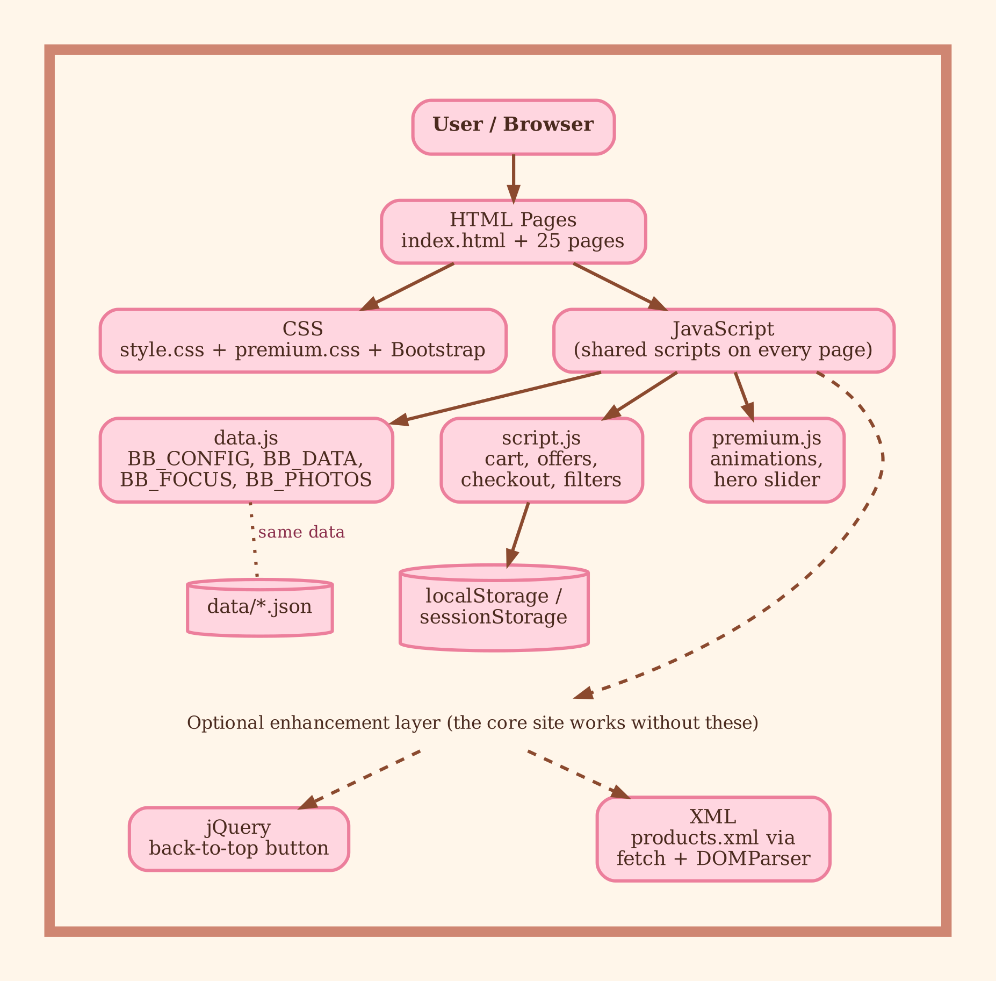
Figure 6.1 – Architecture of Bakerz Bite

7. Project Folder & File Structure
bakerz-bite/
│
├── index.html Home page
├── ReadMe.doc Project read-me
│
├── html/ 25 inner pages
│ ├── menu.html All products + filters
│ ├── cakes.html, cupcakes.html, pastries.html, croissants.html,
│ │ donuts.html, cookies.html, breads.html, pizza.html,
│ │ pies-tarts.html, coffee.html, tea.html, hot-drinks.html,
│ │ cold-drinks.html, merchandise.html (14 category pages)
│ ├── offers.html Deals and offers
│ ├── our-story.html About us, video, bakers
│ ├── gallery.html Photo gallery + lightbox
│ ├── reviews.html Customer reviews + add review
│ ├── contact.html Contact form, map/info, hours
│ ├── faq.html FAQ accordion
│ ├── cart.html Full cart page
│ └── privacy.html, terms.html, sitemap.html (+ XML demo)
│
├── css/
│ ├── style.css Base styles (≈1180 lines): variables, layout, components
│ └── premium.css Enhancements (≈690 lines): Wishlist, filters, checkout, effects
│
├── js/
│ ├── data.js Config + all catalogue data (BB_CONFIG, BB_DATA, BB_FOCUS, BB_PHOTOS)
│ ├── icons.js SVG illustrations (BB_ART)
│ ├── script.js Main application logic (≈1670 lines)
│ ├── premium.js Scroll progress, hero slider, spotlight, count-up
│ ├── jquery-enhancements.js jQuery back-to-top button
│ └── xml-catalog.js XML fetch + DOMParser demo
│
├── data/ Data as separate JSON/XML files
│ ├── products.json, products.xml, categories.json, offers.json,
│ │ reviews.json, faqs.json, gallery.json, cities.json,
│ │ contact.json, config.json
│
├── images/
│ ├── hero/ (hero poster)
│ ├── products/ (product photos)
│ ├── categories/ (category cards)
│ ├── gallery/ (gallery photos)
│ ├── chefs/ (7 baker portraits)
│ ├── favicon.svg
│ └── our-story-poster.jpg (video poster)
│
└── videos/
└── our-story.mp4

8. HTML Implementation
8.1 Common page template. Every page uses the same skeleton: <!doctype html>, lang="en", UTF-8, viewport meta (responsive), meta description, page-specific <title>, favicon, Google Fonts, Bootstrap CSS, style.css, premium.css.
<body data-page="cart" data-nav="">
<div class="app-shell">
<div id="bb-symbols"></div>
<a href="#main" class="skip-link">Skip to content</a>
<div class="floating-bg" id="bb-float" aria-hidden="true"></div>
<header class="bb-nav" id="site-header"></header>
<main id="main" class="app-main"> ... page content ... </main>
<footer class="bb-footer" id="site-footer"></footer>
<div id="bb-overlays"></div>
<div class="bb-ticker" id="bb-ticker"></div>
</div>
<script src="../js/data.js"></script> ...
8.2 Key points
- Semantic elements: <header>, <main>, <section>, <footer>, <nav>, <figure>, <h1>–<h3> hierarchy.
- Placeholders / mount points: #site-header, #site-footer, #bb-overlays, #cart-page, #home-categories, #home-best are empty in HTML and filled by JavaScript, so header/footer are written only once in JS instead of 26 times.
- Custom data attributes: data-page (tells JS which page it is), data-nav (highlights the active menu link), data-reveal (scroll animation), data-icon (SVG icon name), data-hero (hero slider).
- Accessibility: skip link, aria-label, aria-live="polite", aria-pressed, role="img", alt text, aria-hidden on decorative items.
- Performance hints: preconnect for fonts, fetchpriority="high" and width/height on hero images, decoding="async".
- Forms: Contact form, newsletter form, review form, and checkout form use proper <label>, type="email", type="tel", required, and validation messages.
- Script loading order (end of body): data.js → icons.js → script.js → premium.js → jQuery → jquery-enhancements.js. The Sitemap page loads xml-catalog.js.
- Category pages: All 14 category pages are identical in structure (55 lines each) — only data-page/title differ; products are injected by initCategoryPage().
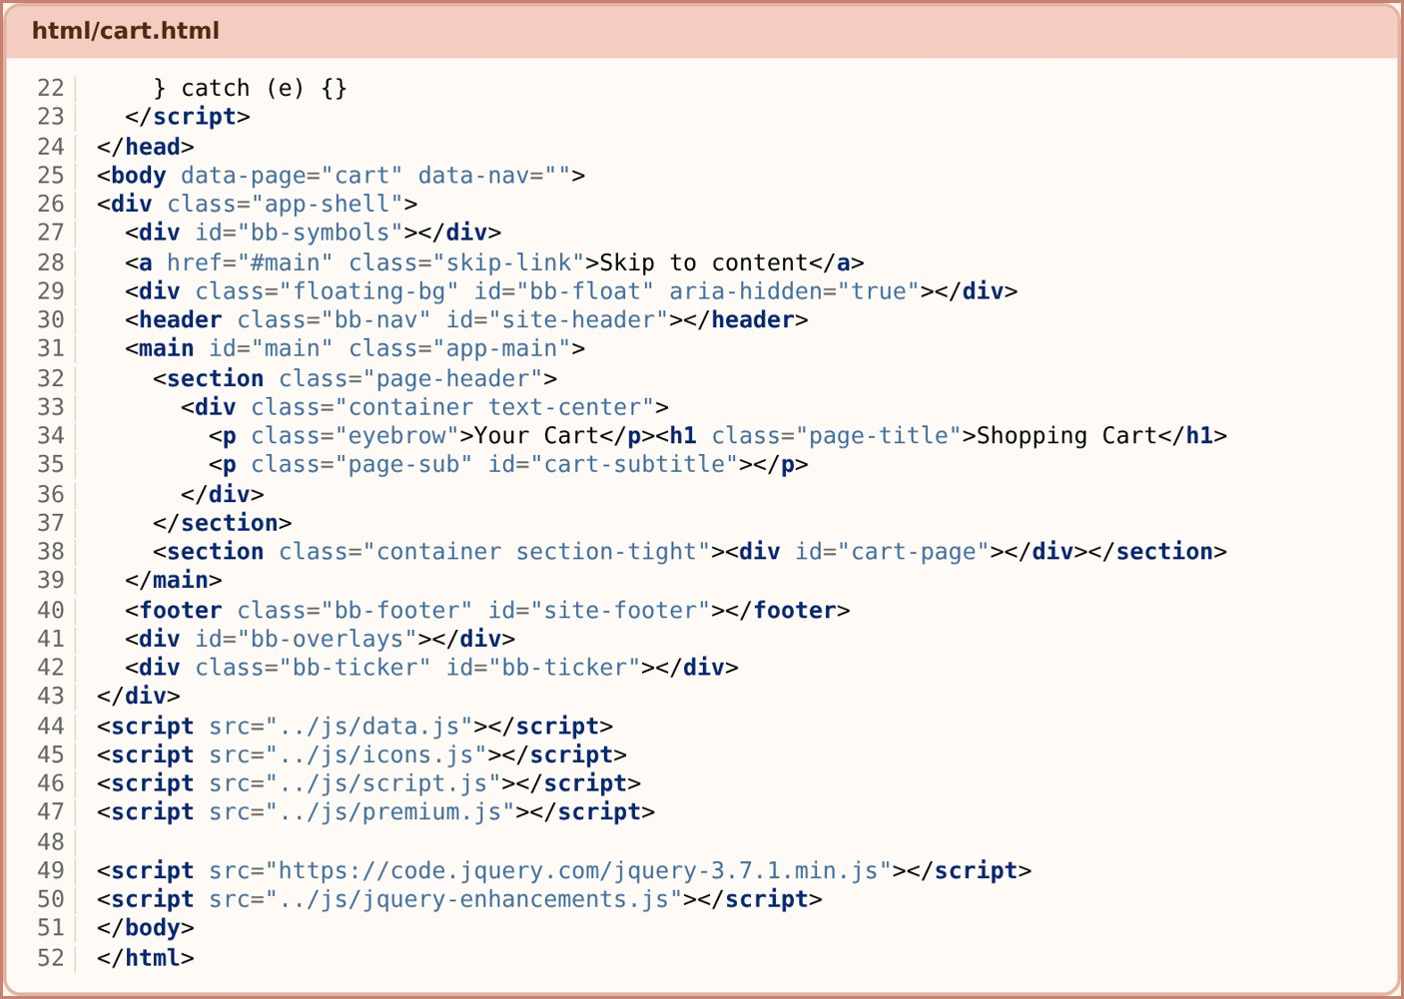
Figure 8.1 – Source code – html/cart.html (body, mount points and script loading order)

9. CSS Implementation
9.1 Files: style.css = base design system; premium.css = later upgrades that override/extend it (loaded after).
9.2 CSS variables (design tokens) in :root (final values from premium.css):
:root {
--cream: #FFFAF6; --blush: #F2C4B5; --rose: #B06A59; --brown: #765044;
--caramel: #A0604C; --ink: #3D2925;
--bg: var(--cream); --surface: #FFFFFF; --text: var(--ink); --heading: var(--brown);
--radius:22px;
--font-head:'Fraunces','Iowan Old Style',...; --font-body:'Nunito',...;
--nav-h:72px;
}
Changing one variable changes the whole theme (peach / cream bakery palette).
Colour palette. The site uses a soft peach, cream and coffee-brown bakery palette (final values come from premium.css, which loads after style.css and overrides it). Each colour is a CSS variable, and the dark theme redefines the same variables with darker values.
Colour | CSS variable | Light | Dark | Used for
Cream | --cream / --bg | #FFFAF6 | #2A1C19 | Page background
Ivory | --ivory / --bg-alt | #FBEFE8 | #33231F | Alternate section background
Surface | --surface | #FFFFFF | #3D2925 | Cards, modals, cart drawer
Blush | --blush | #F2C4B5 | #F2C4B5 | Soft peach fills, chips, buttons
Rose | --rose | #B06A59 | #E3A89A | Main accent, borders, highlights
Rose text | --rose-text | #8F5445 | #F2C4B5 | Small accent text, labels
Caramel | --caramel | #A0604C | #F2C4B5 | Warm accent and hover colour
Coffee mocha | --brown / --heading | #765044 | #F2C4B5 | Headings and logo text
Deep espresso | --ink / --text | #3D2925 | #F7EAE1 | Body text
Link | --link | #8F5445 | #F2C4B5 | Links
Dusty peach | --gold / --dusty-peach | #D99587 | #D99587 | Gold accent, buttons, focus ring
Champagne | --champagne | #D8B779 | #D8B779 | Borders, dark-mode focus ring and accents
Table 9.1 – Colour palette (light and dark theme)
9.3 Dark mode: html.dark {--bg:#2A1C19; ...} — JS toggles class dark on <html> and saves choice in localStorage (bb-theme). An inline script in <head> applies to it before the page paints (no flash).
9.4 Layout techniques
- Bootstrap grid for sections (row g-4, col-12 col-sm-6 col-lg-3).
- CSS Grid for product grid (1 col → 2 col at 480px → 3 col at 992px → 4 col at 1280px), category grid (3 → 6 columns), gallery grid (1 → 3 → 4 columns).
- Flexbox for navbar, buttons and cards.
- aspect-ratio variables for consistent image sizes.
9.5 Components styled: navbar (.bb-nav), hero (.hero, .hero-arch, .mascot), buttons (.btn-gold, .btn-ghost-gold, .btn-soft), cards (.panel-glass, .value-card, .product-card), cart drawer, modal (.pm-grid), chips (.chip-opt), lightbox, FAQ accordion, review carousel (.rc-card), ticker (.bb-ticker), toast, checkout form, footer.
9.6 Effects & animation: @keyframes for floating background, hero mascot, nav fade-in, open-status pulse dot; scroll-reveal via [data-reveal]; hover lift and shadows; glassmorphism (--glass, backdrop-filter); count-up numbers; soft custom shadow variables (--shadow-sm/md/lg).
9.7 Responsive design: mobile-first media queries at 420px, 480px, 576px, 768px, 992px, 1200px, 1280px; navbar collapses into a mobile menu below 992px; the mascot hides below 768px; touch devices get bigger buttons via @media (pointer: coarse); hover-less devices always show gallery captions via @media (hover: none).
9.8 Accessibility in CSS: @media (prefers-reduced-motion: reduce) disables animations; visible focus styles; .skip-link; sufficient color contrast variables (--rose-text, --link).
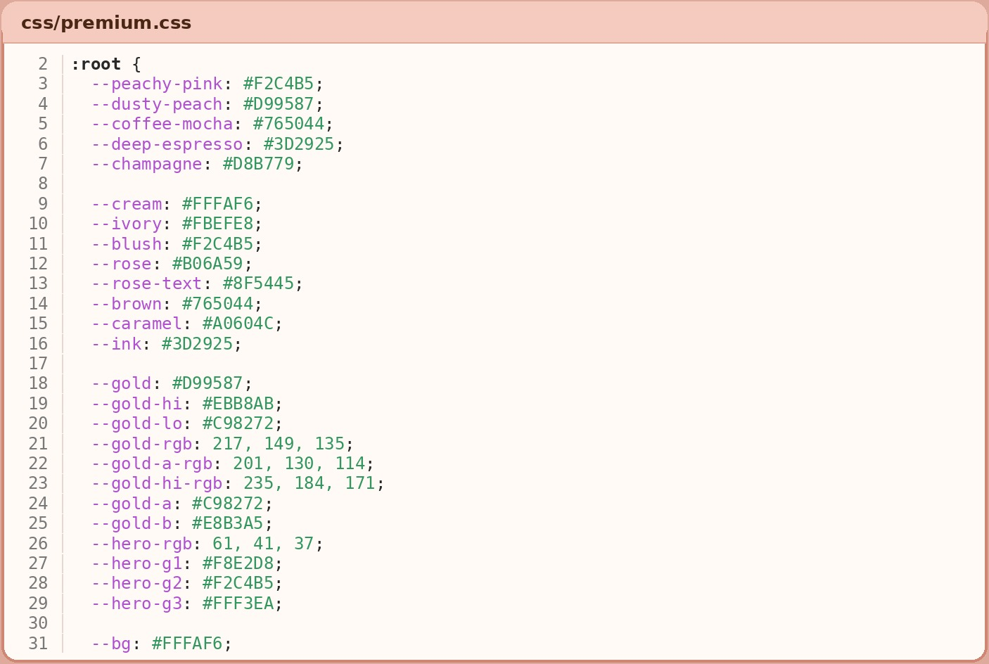
Figure 9.1 – Source code – CSS variables in :root (premium.css)

10. JavaScript Implementation

10.1 Files and responsibilities
File | Responsibility
data.js | Data store (BB_CONFIG, BB_DATA, BB_FOCUS, BB_PHOTOS)
icons.js | BB_ART — SVG illustrations for products without photos
script.js | Entire application logic inside one IIFE (no global pollution)
premium.js | Scroll-progress bar, hero image slider, mouse spotlight, count-up stats (IntersectionObserver)
jquery-enhancements.js | Back-to-top button (jQuery animate)
xml-catalog.js | fetch() + DOMParser to read products.xml

10.2 script.js module-wise explanation
- Helpers — $/$$ (querySelector shortcuts), esc() (escapes HTML to prevent XSS), money() (formats Rs. 3,200), loadJSON/saveJSON (safe localStorage wrappers), getProduct, getCategory, pageLink (correct relative paths for root vs /html pages).
- Theme — applyTheme(), currentTheme(); saved key bb-theme.
- Cart engine
  - unitPrice(product, options) — base price × size multiplier + flavour + decorations + toppings.
  - validateOptions() — size/frosting/flavour are required where applicable.
  - lineKey() — unique key per product+options, so the same cake with different options is a separate line.
  - addItem, setQty, removeItem, clearCart, saveCart (→ localStorage key bb-cart), renderCartUI, renderCartPage.
- Offer engine — `applyOffers()` (automatic, no coupon code)
  - 8″/10″ cakes: 15 % off
  - Every pair of pastries: 10 % off
  - Each coffee + cookie: 20 % off the cookie
  - Large pizza: 10 % off
  - Also produces "hint" messages (e.g., Add one more pastry to get 10 % off).
- `totals()` — subtotal, discount, delivery (free if amount after discount ≥ Rs. 5,000, else Rs. 250), grand total, item count.
- Layout renderer — `renderShell()` builds the navigation (NAV array), footer, cart drawer, ticker, search overlay and modals on every page; visitorCount() increments bb-visits.
- Ticker & location — renderTicker(), tickTime() shows date/time in Asia/Karachi time zone, open/closed status via openStatus() (reads opening hours from config), and saved location (bb-location) chosen from LOC_CITIES with distanceKm() calculation.
- UI helpers — toast(), openCart/closeCart, openModal/closeModal, trapTab() (keyboard focus trap for accessibility).
- Product modal — openProduct(id), pmChipClick, pmUpdateTotal, pmAdd: shows image, ingredients, allergens, customisation chips and live total.
- Dietary filter & wishlist — DIETS, dietOk() (regex checks of ingredients and allergens → egg-free, nut-free, dairy-free, gluten-free, vegan), toggleWish() (bb-wishlist).
- Product browser — `initBrowser()` — filters object {q, cat, maxPrice, sort, rating, popular, isNew, sale, saved, diet}; search, sort (featured / price / rating), renders via cardHtml() + gridHtml().
- Checkout — openCheckout() builds the form (Delivery / Pickup, time slot Morning/Afternoon/Evening, COD / Online). Validators: coName, coEmail, coPhone, coAddress, cardFieldError (card number, name, expiry, CVV). Live input masking (card number groups of 4, MM/YY). submitCheckout() blocks on errors and focuses the first bad field; on success it generates an order reference BB-xxxx, clears the cart, and shows "Order confirmed".
- Reviews — allReviews() merges default reviews with user reviews (bb-reviews), star renderer, avatar generator, initCarousel() (auto-rotating testimonials), initReviewsPage() (rating summary + add-review form).
- Gallery — initGallery() + openLightbox() / drawLightbox() with next/previous.
- Page initialisers — initHome, initHero, initOffers, initFaq, initCategoryPage, renderStaticLists, setupReveal (IntersectionObserver for scroll animation).
- Forms — validEmail(), submitContact(), submitNewsletter().
- Events — `bindGlobalEvents()` — one delegated listener for clicks (add to cart, open product, wishlist, quantity buttons, theme toggle, menu, close buttons), keyboard (Esc closes overlays).
- Intro/welcome screen — startIntro(), renderWelcomeScreen(), renderLocationScreen(); shown once per session (bb-intro-done in sessionStorage).
- Boot — boot() → renderShell() → initPage() → starts intro. Runs on DOMContentLoaded.

10.3 Browser storage keys
Key | Storage | Purpose
bb-cart | local | Cart items
bb-theme | local | dark / light
bb-wishlist | local | Saved product IDs
bb-reviews | local | User-submitted reviews
bb-location | local | Chosen city
bb-visits | local | Visitor counter
bb-intro-done | session | Intro already shown
bb-visit-counted | session | Count visit once per session

10.4 jQuery code (jquery-enhancements.js)
Creates a "↑" button, shows it after scrolling 320 px, and scrolls to top with $('html, body').animate({scrollTop:0}, 450).

10.5 XML code (xml-catalog.js)
On button click: fetch('../data/products.xml') → DOMParser().parseFromString(text,'application/xml') → check parsererror → querySelectorAll('catalog > product') → list the first 8 products (name, price, category). Shows a friendly message if the file is opened without a server.

10.6 Selected source code
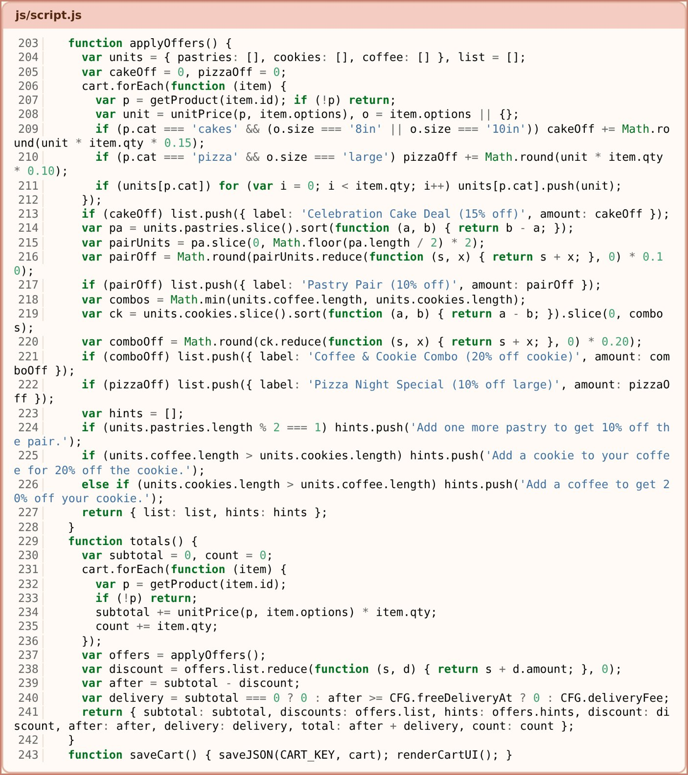
Figure 10.1 – Source code – applyOffers() and totals() (script.js)

11. Website Pages Implementation (with Source Code Screenshots)

11.1 Website screenshots
The screenshots below show the main pages and pop-ups of the website.
Home page. Hero slider, categories and best sellers. Everything is rendered by initHome() from the data in data.js.
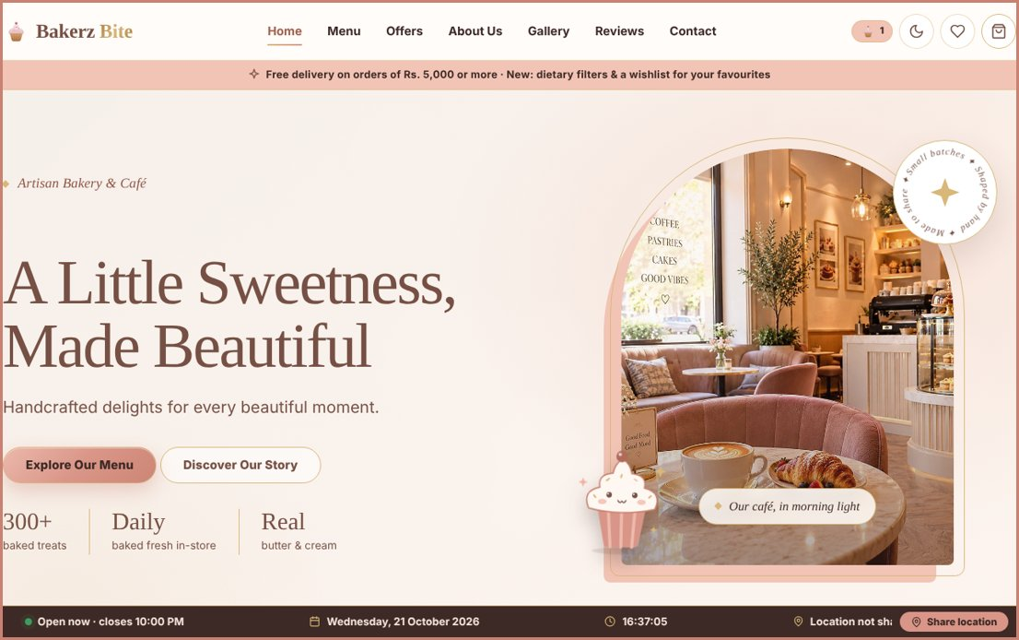
Figure 11.1 – Home page
Menu page. All 56 products with search, category chips, price, rating, sort and dietary filters (initBrowser()).
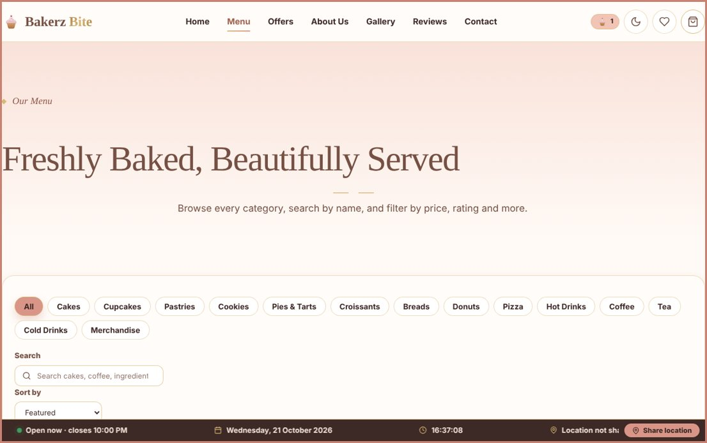
Figure 11.2 – Menu page
Product customisation modal. Ingredients, allergens, size/frosting/decoration options and a live total (openProduct(), pmUpdateTotal()).
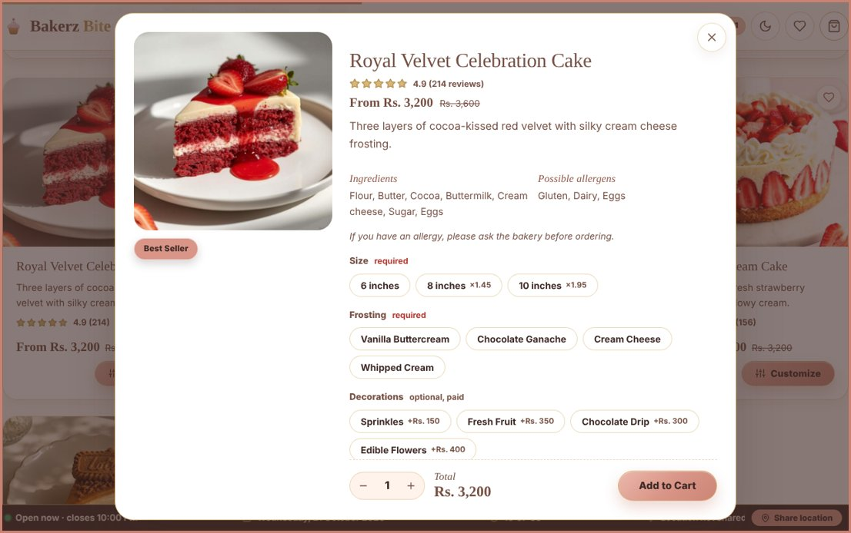
Figure 11.3 – Product customisation modal
Cart drawer. Quantity buttons, automatic offers, delivery fee and total (totals(), applyOffers()).
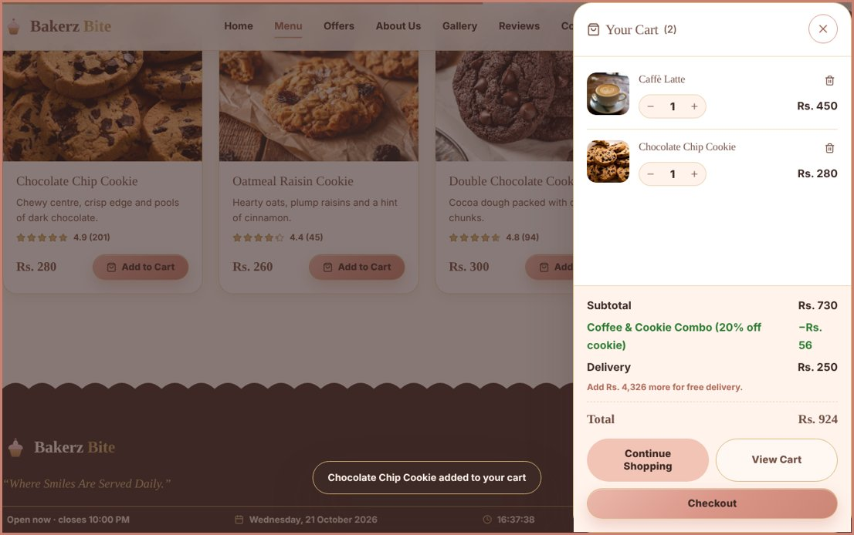
Figure 11.4 – Cart drawer
Checkout with validation. Delivery/pickup, time slot and payment method. Empty or wrong fields show error messages (submitCheckout()).
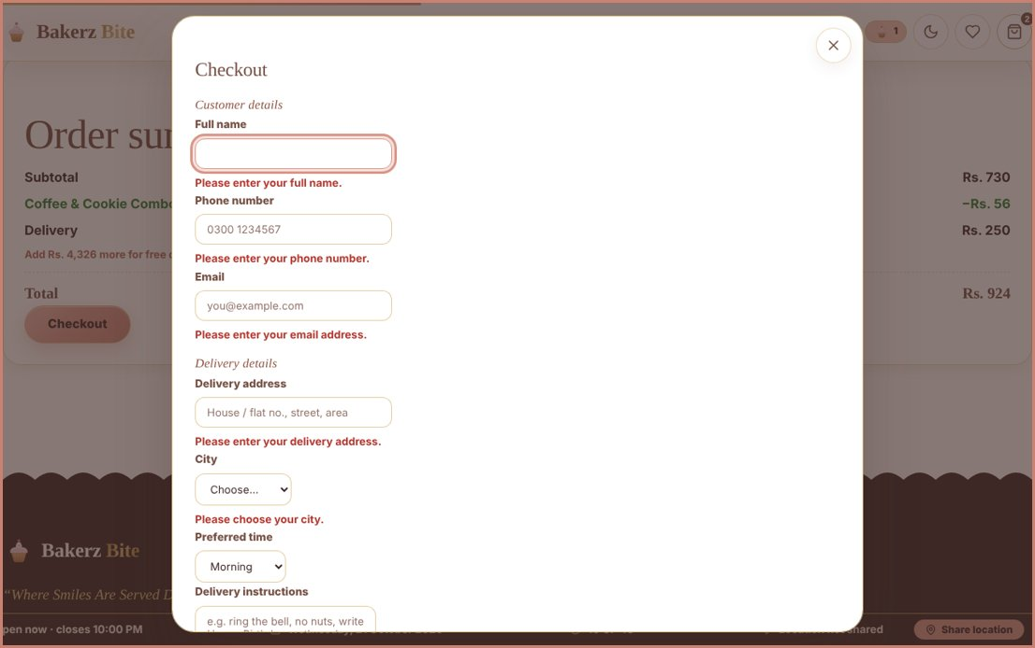
Figure 11.5 – Checkout with validation
Dark mode. The theme toggle adds the class dark to <html>; CSS variables change all colours (saved as bb-theme).
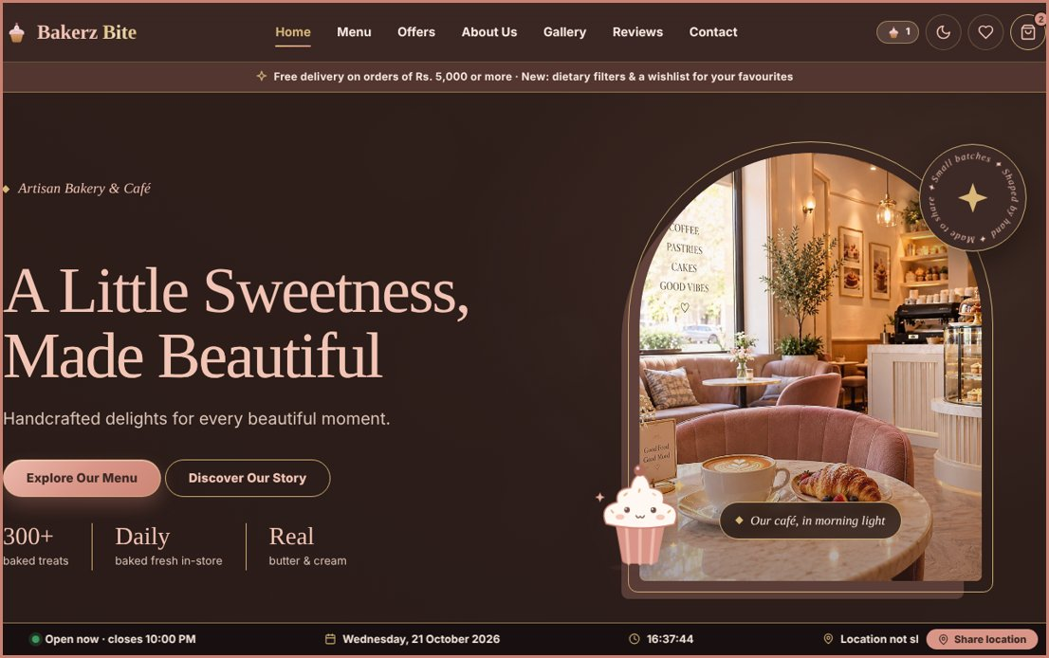
Figure 11.6 – Dark mode

12. Diagrams
This section contains the flowcharts and data flow diagrams of the project. The system architecture diagram is given in Section 6 (Figure 6.1).

12.1 Flowcharts for Various Activities
The flowcharts below show the three most important activities of the shopping process: adding a product to the cart, calculating offers and totals, and checkout. Dark rounded boxes mark the start and end, pink boxes are processing steps, plain rectangles are user inputs and gold diamonds are decisions (Yes / No).
Flowchart 1: Add a product to the cart
From the product modal to the saved cart, including option validation.
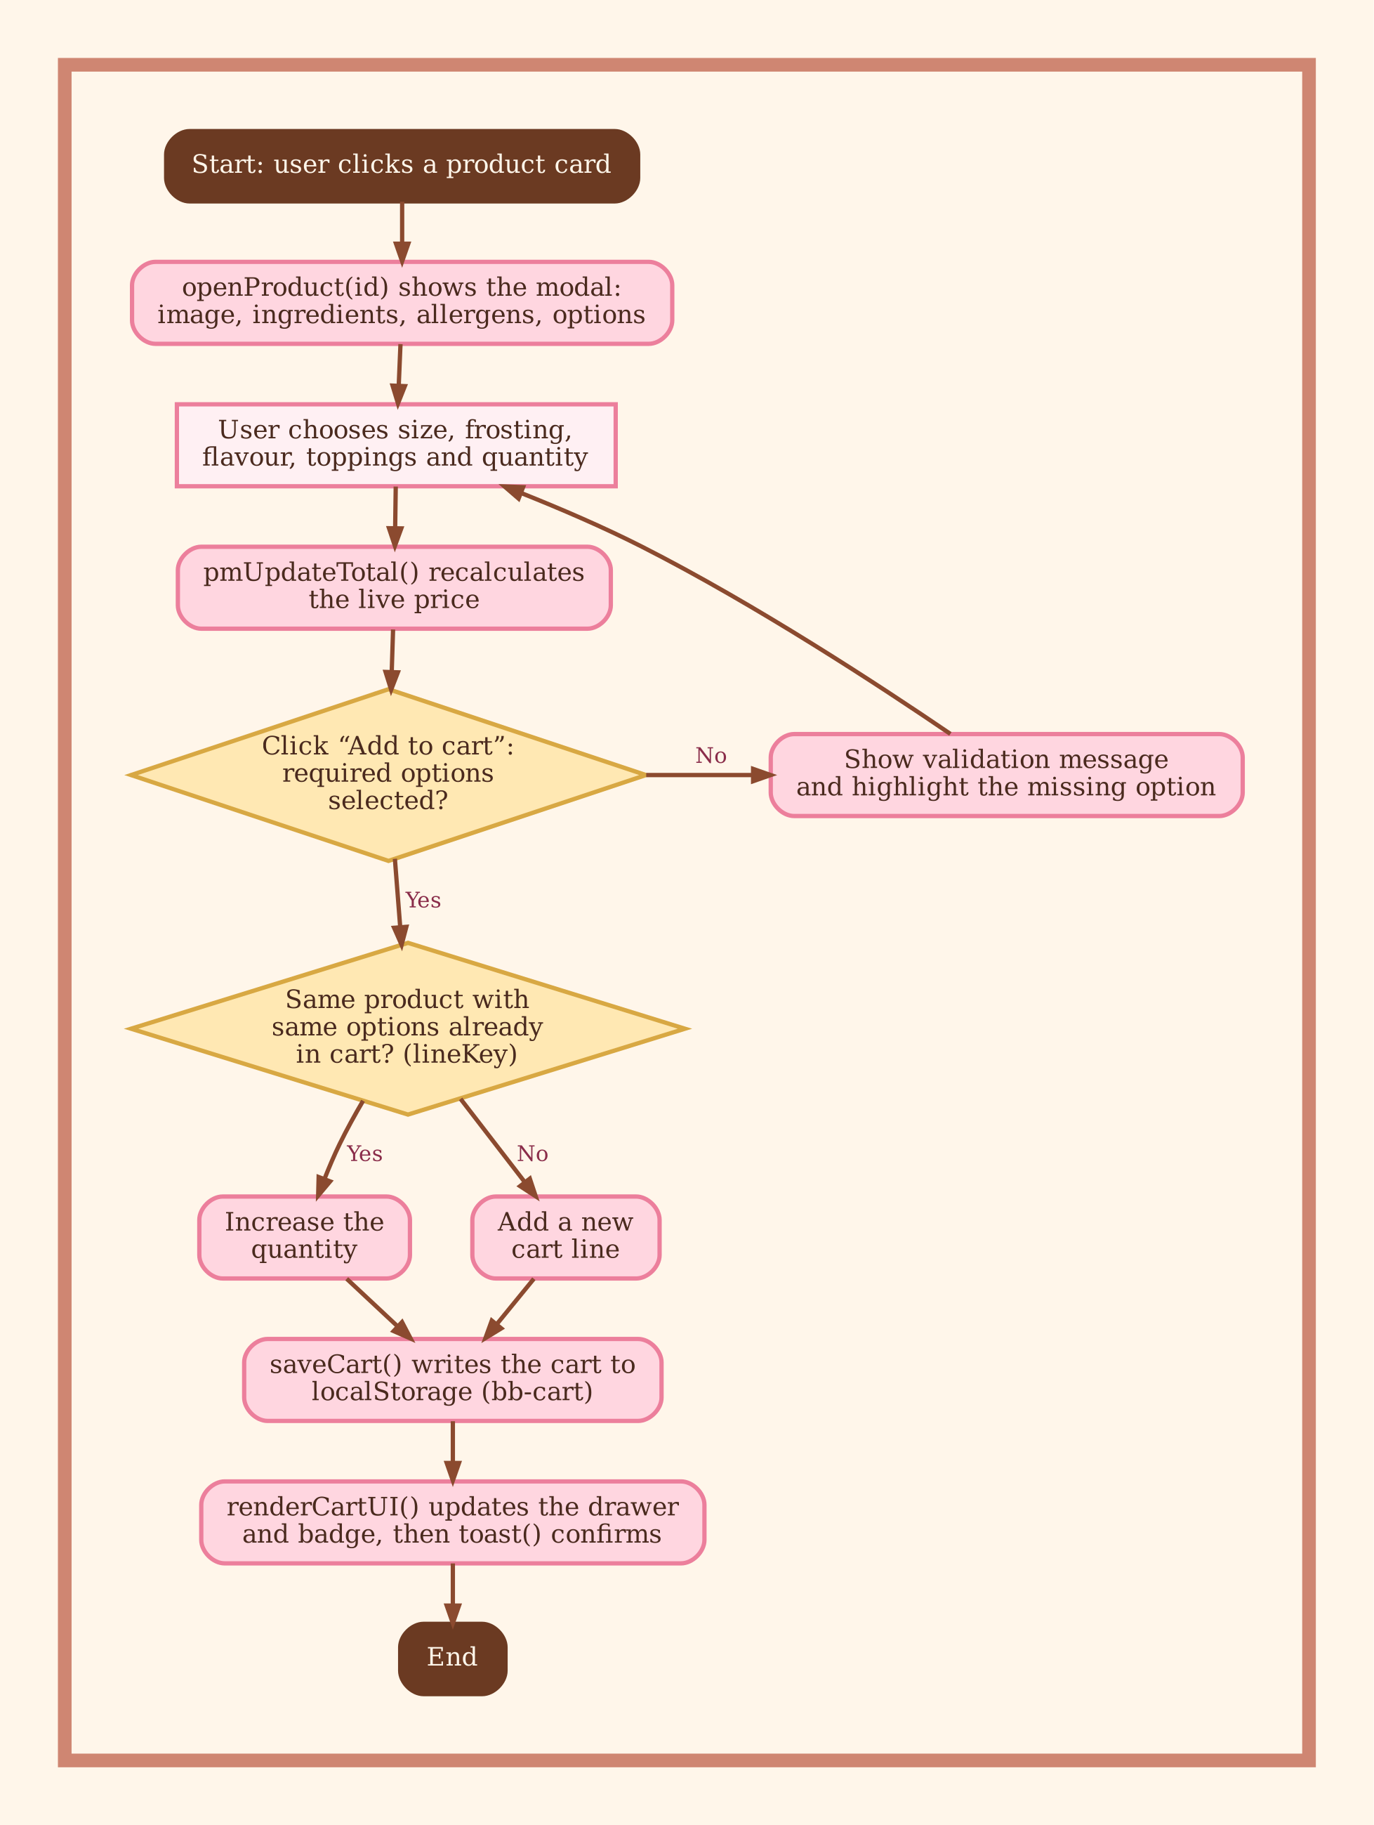
Figure 12.1 – Flowchart: add a product to the cart
Flowchart 2: Offers and total calculation
How the automatic offers, delivery fee and grand total are calculated.
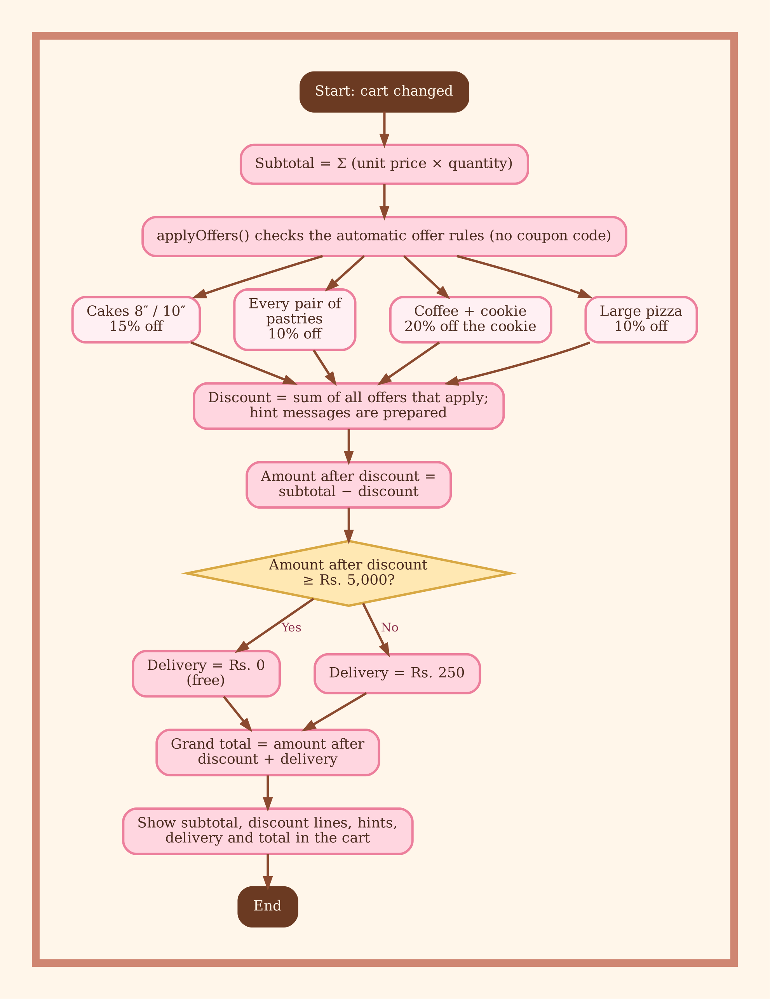
Figure 12.2 – Flowchart: offers and total calculation
Flowchart 3: Checkout and order confirmation
Delivery or pickup, payment choice, validation and the confirmation message.
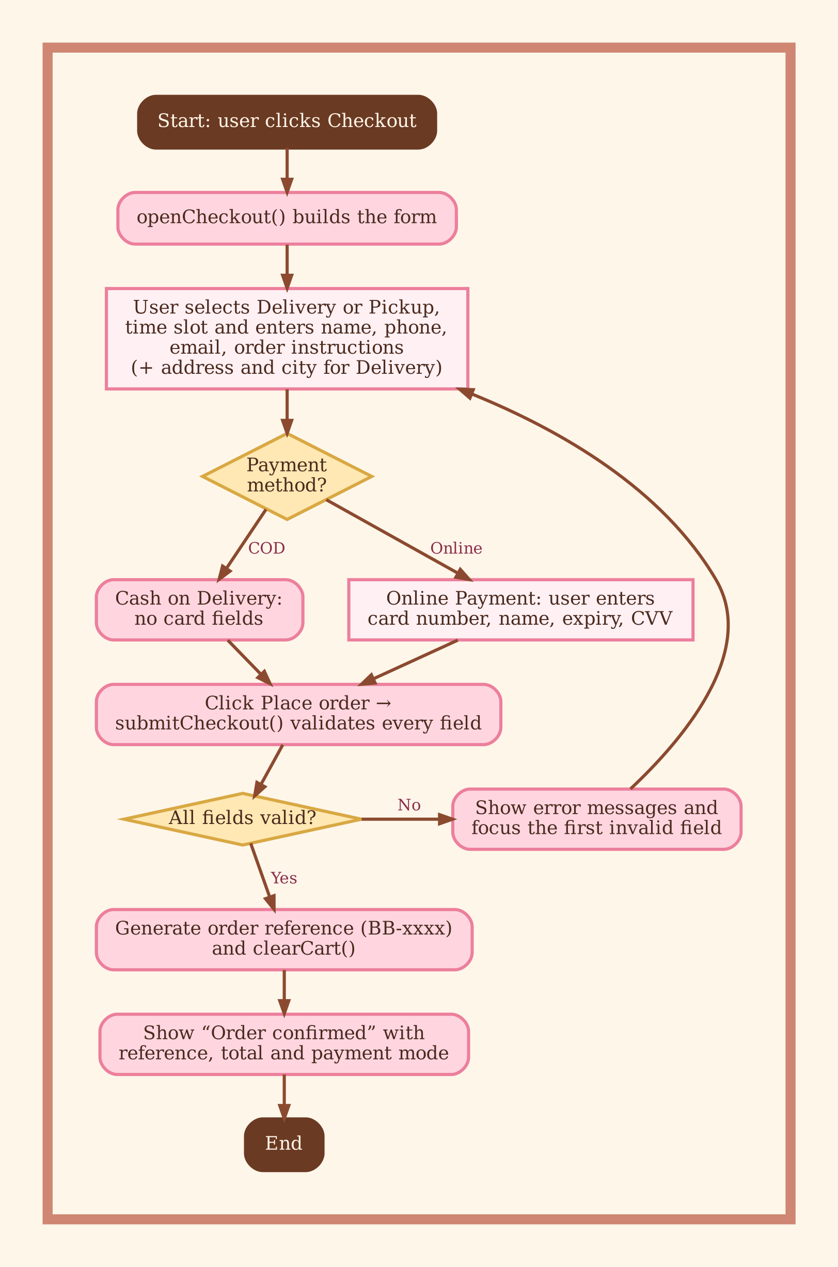
Figure 12.3 – Flowchart: checkout and order confirmation

12.2 Data Flow Diagrams
A Data Flow Diagram (DFD) shows how data moves between the user, the processes of the system and its data stores. Circles are processes, the dark rectangle is the external entity (Customer), open rectangles are data stores and arrows are data flows. Because the project has no back end, the data stores are the product data files (D1, read only) and the browser’s localStorage (D2).
DFD Level 0: Context diagram
The whole website as one process with one external entity, the Customer.
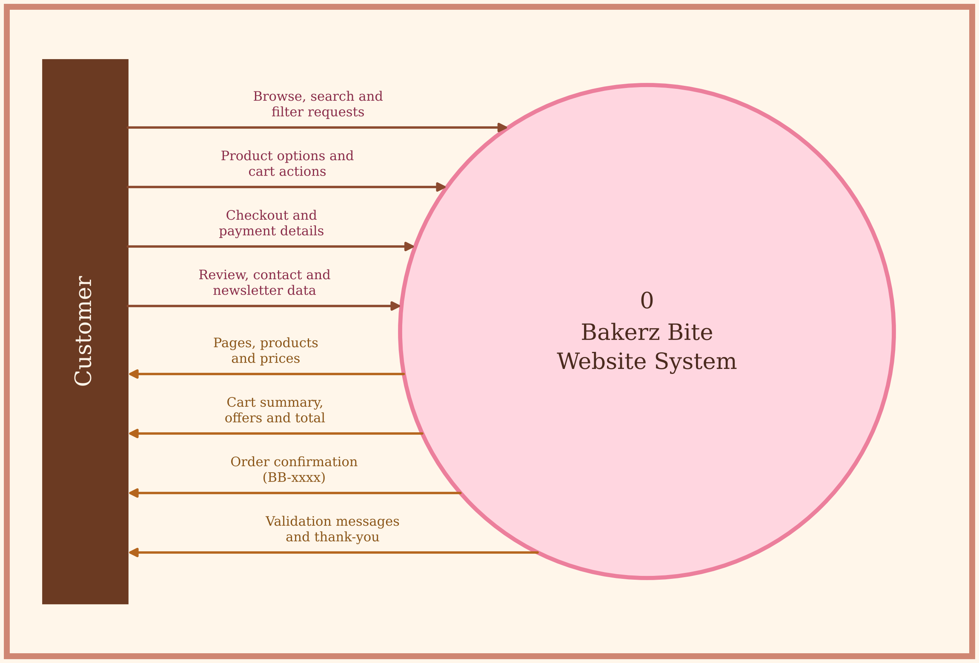
Figure 12.4 – Data Flow Diagram, Level 0 (context diagram)
DFD Level 1: Main processes and data stores
The website split into its five main processes and two data stores.
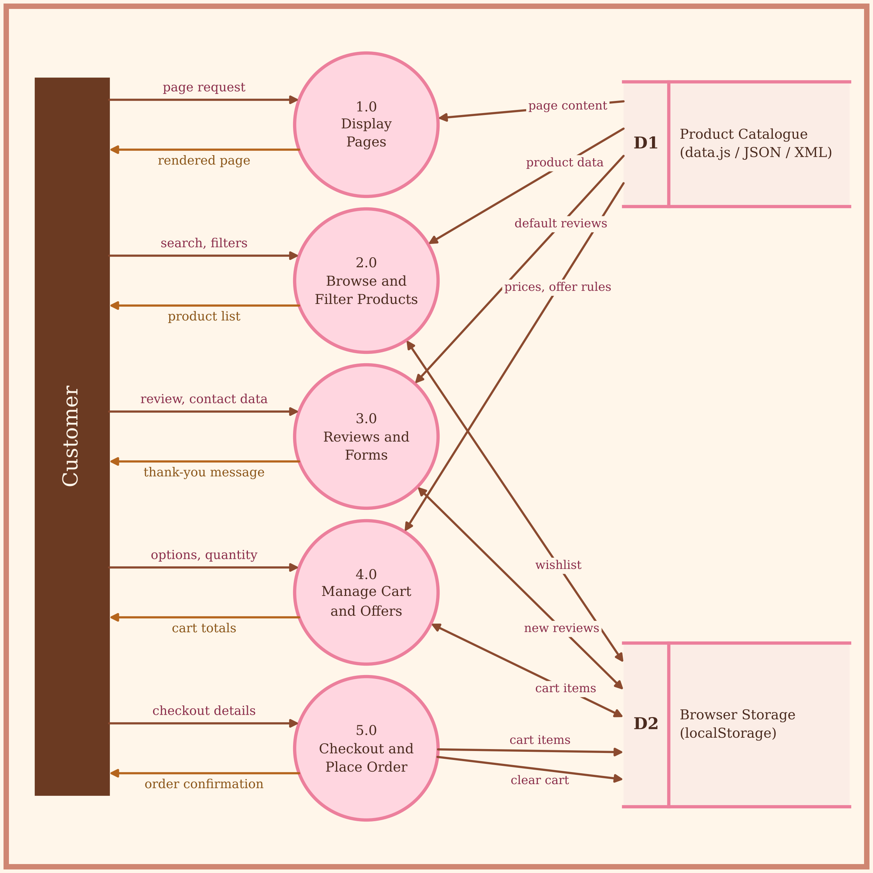
Figure 12.5 – Data Flow Diagram, Level 1
1.0 Display Pages – initPage() renders the page; 2.0 Browse and Filter Products – initBrowser(); 3.0 Reviews and Forms – review, contact and newsletter forms; 4.0 Manage Cart and Offers – addItem(), applyOffers(), totals(); 5.0 Checkout and Place Order – submitCheckout().

13. Future Scope
- Back-end & database — Node.js/Express (or PHP/Django) with MongoDB/MySQL to store products, users and orders instead of static files.
- User accounts — registration, login, order history, saved addresses.
- Real payment gateway — Jazz Cash, EasyPaisa, Stripe or PayPal integration, plus real order confirmation by email/SMS/WhatsApp.
- Admin dashboard — add/edit products, prices, offers, view and manage orders and reviews.
- Live order tracking — status updates (received, baking, out for delivery) with maps.
- Coupon codes, loyalty points and gift cards.
- Progressive Web App (PWA) installable app, offline mode with service workers.
- Multi-language support (English/Urdu) and multi-currency.

14. Conclusion
Bakerz Bite successfully delivers a complete, attractive and responsive bakery website using HTML5, CSS3, JavaScript and Bootstrap, with jQuery and XML integrated as enhancements. The project demonstrates a data-driven design: a single JavaScript application renders 26 pages from a central data file, calculates prices and automatic offers, validates forms, and keeps the cart, Wishlist, theme and reviews in the browser's storage. Accessibility, dark mode and responsive layout make the site usable for a wide range of people and devices.
During development, the team learned how to structure a multi-page project, create reusable components without a framework, manage state in the browser, validate user input, and document a project professionally. Although the current version works entirely on the client side, its modular structure allows easy extension with a back end, payment gateway and admin panel in the future. The project therefore meets its objectives and provides a solid foundation for a real-world online bakery.

